**TUTORIAL – 1**

[gist.githubusercontent.com/nikkiray309/46126927feca96c67303071007c928d9/raw/9293d73f91823344542229f2660fc6ca474c75c6/tutorial-1.csv](https://gist.githubusercontent.com/nikkiray309/46126927feca96c67303071007c928d9/raw/9293d73f91823344542229f2660fc6ca474c75c6/tutorial-1.csv)

dataset link: [raw.githubusercontent.com/nikkiray309/sdv-act6/refs/heads/main/Activity6_Population.csv](https://raw.githubusercontent.com/nikkiray309/sdv-act6/refs/heads/main/Activity6_Population.csv)

VizHub Link: <https://vizhub.com/nikkiray309/95802fce6c3a4bf0b9112a5ddaf54f07>

**Explanation:** In this tutorial, I have created links for data using GitHub and Gist then, I have created a bar chart using d3.js and use the links created to read the data. This data is extracted and used for visualizations in Vizhub.

**Question 1:**

VizHub Link: <https://vizhub.com/nikkiray309/8cbed5e3e04141c9aea98705c5d0ab5c>

**Question 2:**

VizHub Link: <https://vizhub.com/nikkiray309/ce33b0d5cbcc43b7b7fb8395c7bc7159>

**Explanation:** In this tutorial, we have used the ‘Activity6_population’ dataset to compare the population of different countries. For 1st question, 10 countries population(2000 year) is compared and for 2nd question – 20 countries' population(year-2010) is taken.

**TUTORIAL – 2**

VizHub Link: <https://vizhub.com/nikkiray309/103ab68b50764d08945332d9e53dc910>

**Explanation**: In this tutorial, I created a data set named ‘data.csv’ in VizHub to display the genre ratings using a stacked bar chart. I have also given different colors for different ranges.

**Question 3:**

VizHub Link: <https://vizhub.com/nikkiray309/277ab4953f834787be39d78ac87dbd4e>

**4. Dataset Explanation:**

I have taken the data set called **company_data.csv** from Kaggle. This data set contains 4 attributes namely - TV, radio, newspaper, and sales. It describes on much budget different categories gave how much sales. All the columns are numerical attributes.

**5. Chart Explanation:**

The stacked bar chart gives us an overview of the budgets of different categories, such as TV, Radio, and Newspapers. I have taken 5 data points from the data.csv file for this graph.

**TUTORIAL – 3**

Dataset Link: <https://raw.githubusercontent.com/nikkiray309/sdv-act6/refs/heads/main/iris.csv>

Gist Link: <https://gist.githubusercontent.com/nikkiray309/9d2b10a0fd4e39cad06f2757333e24c5/raw/4f67b5bf112a23d117a87a9530ea0756f0f6cc0a/iris.csv>

VizHub Link: <https://vizhub.com/nikkiray309/86199b7c090547bba84797d369c3b3f5>

**Tutorial 3.2**

VizHub Link: <https://vizhub.com/nikkiray309/b0f16ff7c36e4c2bbc5051080cf143a4>

**Explanation:** In this tutorial, we have plotted scatter plots in two different ways. First, we have used colors to describe data points of different iris flower types. For the second time, we have you used shapes to identify different species of iris flower.

**Question 6:**

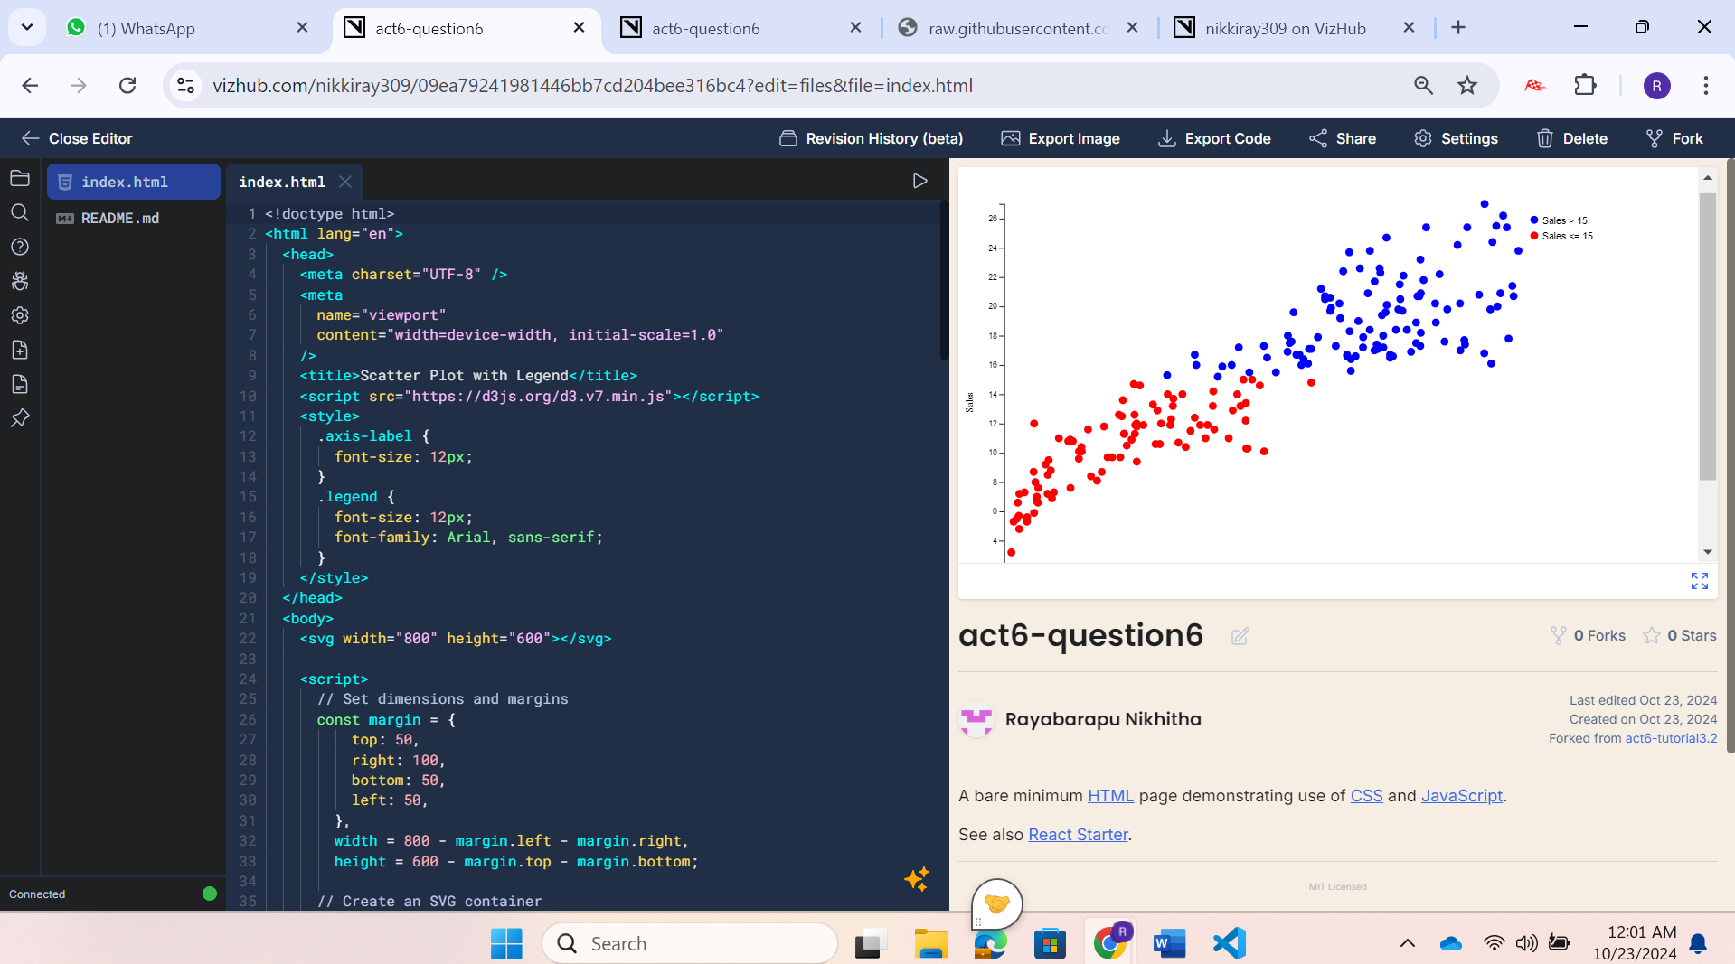

VizHub Link: <https://vizhub.com/nikkiray309/09ea79241981446bb7cd204bee316bc4>

**7. Dataset Explanation:**

I have taken the data set called **company_data.csv** from Kaggle. This data set contains 4 attributes namely - TV, radio, newspaper, and sales. It describes on much budget different categories gave how much sales. All the columns are numerical attributes.

**8. Chart Explanation:**

The chart is a scatter plot that takes sales on the Y-axis and TV Budget on the X-axis. We can observe that there is some kind of linear relationship between sales and TV. The sales value less than or equal to 15 is in red and greater than 15 is described in blue color.

**TUTORIAL – 4**

VizHub Link: <https://vizhub.com/nikkiray309/8578c04ec61b42a796773b6b2557e5e5>

**Explanation:** In this tutorial, we have plotted Bubblechart for the bubblechart.csv file. I have created a bubbleChart.csv file and pasted the data into it. The X-axis has Avg Horsepower and Y-axis has Avg. Torque. Color describes different brands and MPG’s.

**Question 9:**

**VizHub Link:** <https://vizhub.com/nikkiray309/4ca3766543a34097800286199d10b2a5>

**10.** **Dataset Explanation:**

I have taken the data set called **company_data.csv** from Kaggle. This data set contains 4 attributes namely - TV, radio, newspaper, and sales. It describes on much budget different categories gave how much sales. All the columns are numerical attributes.

**11. Chart Explanation:**

The bubble chart takes the TV budget on the X-axis and the Radio budget on the Y-axis. The size of the bubbles on the chart shows the amount of sales produced by both categories.